House Hunt — Technology Stack
Components, technologies, and the architecture connecting them
House Hunt is built entirely on the MERN stack (MongoDB, Express.js, React, Node.js), with a small, deliberately lean set of supporting libraries rather than a large external-service footprint. This document lists every component actually used in the codebase, organized by architectural layer.

Architecture Overview

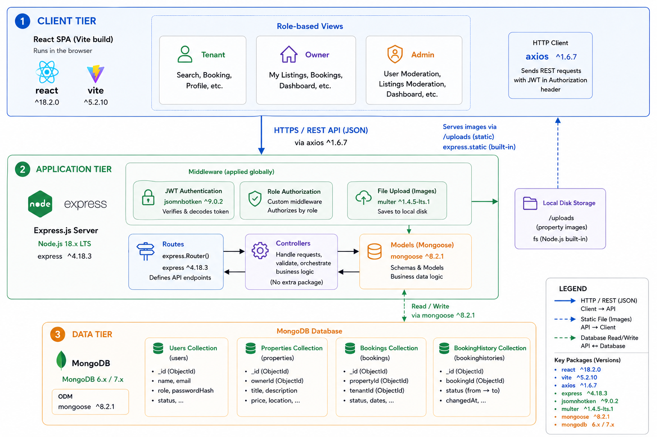

Table 1 — Components & Technologies
S.No. | Component | Description | Technology
1. | User Interface | How Tenants, Owners, and Admins interact with the application | React 19 (Vite build), React Router v7, Bootstrap 5, MUI (Material-UI), Framer Motion
2. | Application Logic — Auth | Registration, login, JWT issuance/verification, role & approval gating | Node.js, Express.js 4, jsonwebtoken, bcryptjs
3. | Application Logic — Listings & Search | Property CRUD, search/filter queries, amenity matching | Express.js controllers/routes, Mongoose query API
4. | Application Logic — Bookings | Booking request creation, confirm/cancel workflow, view/booking history logging | Express.js controllers/routes, Mongoose
5. | Database | Primary data store for users, properties, bookings, and history | MongoDB with Mongoose ODM (schema/validation layer)
6. | File Storage | Property image uploads (up to 5 per listing, 5MB max, jpeg/jpg/png/webp) | Multer (disk storage), served via Express static route
7. | HTTP Client | Client-to-API communication layer with automatic JWT attachment | Axios (shared instance with request interceptor)
8. | External API-1 | None currently integrated — no maps, email, or payment service in use | Not applicable

Table 2 — Application Characteristics
S.No. | Characteristic | Description
1. | Availability | Stateless JWT authentication allows the API layer to run across multiple instances without a shared session store.
2. | Security | Passwords hashed with bcrypt; JWT-based route protection; role-based authorization middleware; ownership checks on edit/delete actions; image type/size validation on upload.
3. | Scalability | Decoupled REST API and SPA frontend; MongoDB supports sharding/replica sets; horizontal scaling of the Express layer is possible without session-affinity requirements.
4. | Performance | Search/filter queries run directly against Mongoose queries on indexed fields (location, rent, property type), keeping response times low for the platform's current data volume.
5. | Maintainability | MVC structure (routes/controllers/models) keeps business logic, request handling, and data schema cleanly separated across a single unified codebase for all three roles.

What's Deliberately Not in the Stack
To keep the architecture accurately represented, it's worth noting explicitly what House Hunt does not use today: no cloud image storage (Cloudinary/Firebase/ImageKit — images are stored on local disk via Multer), no third-party maps (Google Maps or otherwise), no transactional email service (Nodemailer/SendGrid/Brevo), no OAuth providers (Google/LinkedIn/Facebook login), and no payment gateway. Each of these would be a natural, low-friction addition to the existing architecture but is out of scope for the current build.

